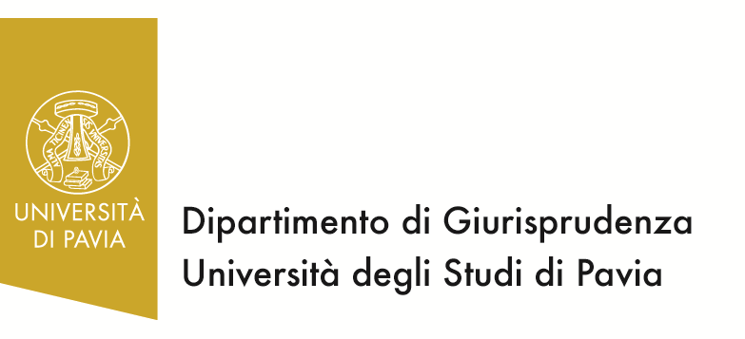
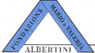

Centro Studi
sull’Unione Europea
Centro di documentazione europea

Dottorato in diritto pubblico, giustizia penale e internazionale

THE EUROZONE: FROM A MONETARY UNION
TO AN ECONOMIC AND POLITICAL UNION

Wednesday 15th May 2013, University of Pavia, Aula Foscolo

9.15: Greetings from the Dean of the Law Faculty

9.30 – 10
Introduction
Giulia Rossolillo (Professor of EU Law, University of Pavia)

10.00 – 10.40
The blueprint of the European Commission
for a deep and genuine economic and monetary Union
Marie Donnay (Assistant to the Director General, DG Ecfin, European Commission)

10.40 – 11.20
An economic policy for the Eurozone: from governance to government
Jean-François Jamet (Economist at the European Central Bank)

11.20 – 12.00
The principle of solidarity in the Economic and Monetary Union
Alexandre De Streel (Professor of EU Law, University of Namur)

Debate

